GUJARAT TECHNOLOGICAL UNIVERSITY

**Dr. Jivraj Mehta Institute Of Technology**

A

Report on

DIGITAL CANTEEN SERVICE

Under subject of DESIGN ENGINEERING – 1

B. E. II, Semester – IV

(Computer Engineering)

djmit logo.png

Submitted by :

**Group:**

|  |  |  |
| --- | --- | --- |
| Sr.No. | Name of student | Enrollment No. |
| 1. | Anjali Suryavanshi | 220823107013 |
| 2. | Pragya Tiwari | 220823107015 |
| 3. | Aditi Gupta | 220823107005 |

**Prof. Kush Patel**

(Faculty Guide)

**Prof. Hetal Chokshi**

(Head Of the Department)

Academic Year (2022-2023)

|  |  |  |
| --- | --- | --- |
| CHAPTER 1  CHAPTER 2  CHAPTER 3  CHAPTER 4 | TABLE OF CONTENTS  INTRODUCTION   * 1. Introduction to Concept/Idea   PHASE 1: REVERSE ENGINEERING   * 1. Introduction and study of components/product for reverse engineering   2. Details of canvases using Design Thinking based on reverse engineering   3. Literature Review / Prior Art Search   4. Feedback/Summary of the learning from Reverse Engineering activity   PHASE 2: PREDESIGN   * 1. Pre-design calculation   2. Learning Needs Matrix (LNM)   PROTOTYPE MODEL   * 1. Features/Functions of proposed system   2. Fast Prototype Model/Conceptual Plan Layout   CONCLUSION REFERENCES | 1  1  2  3  9  14  15  15  17  17  18  19 |

|  |  |  |
| --- | --- | --- |
| LIST OF FIGURES  2.2.1  2.2.2  2.2.3  2.2.4  2.3.1 to 2.3.5  3.3.2  4.2 | AEIOU Summary Empathy Mapping Canvas Ideation Canvas  Product Development Canvas Websites Photos  Learning Need Matrix  Fast Prototype Model/Conceptual Plan Layout | Page No  5  6  7  9-14  15  17 |





# Chapter 1: Introduction

* 1. Introduction to concept/idea

Obesity in India has reached epidemic proportions in the 21st century. Recent studies have

reported that globally, more than 1.9 billion adults are overweight and 650 million are obese. Approximately 2.8 million deaths are reported as a result of being overweight or obese. Due to the consumption of energy dense food.

As an insufficient source of healthy food for student they have only option to eat junk food and eventually get addicted to that, consequently, student may suffer from obesity issue. For dealing with this situation, we have proposed an online platform where students can get their nutritive food.

In this project the students, faculties or the staff of the college campus place online order for their meal and enjoy the food at the collage doorstep.

Moreover, in college the student and faculties get very less time in order to eat their meal from the college campus canteen. so, by this proposal they can order the food before the recess time and eat conveniently.





# Chapter 2. Phase 1: Reverse Engineering

* 1. Introduction and Study of components/artefact/product for reverse engineering: As part of Design Engineering we have studied a Reverse Engineering on our topic Digital Canteen service. We have studied a few similar platforms and made some useful observations. Almost all of the platform has discount code offer which can be very useful for grabbing attention of target users.

Similarly, a large number of platforms has a text review feature but only few platforms has feature where image and text both can be put in by a user. this can be useful for getting feedback from the customer for different vendors.

After analyzing all the aspects, we are considering a few features as learning from reverse engineering such as a review section and well classified product page of different food items with filter option.





* 1. Details of canvases using designed thinking based on reverse engineering.
     1. 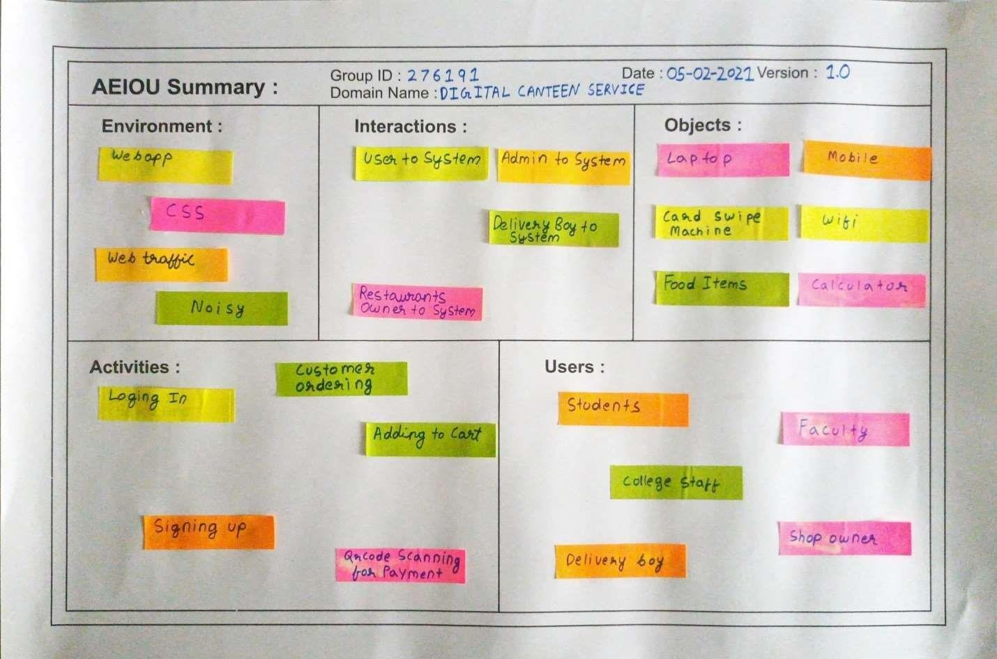AEIOU Summary

Fig. 2.2.1 AEIOU Summary

Activities:

* + - * Customer ordering
      * QR code training for payment
      * Loging in
      * Signing up
      * Adding to cart

Environment:

* + - * Webapp
      * CSS
      * Web Traffic Interaction:
      * User to system
      * Admin to system

Objects:

* + - * Laptop
      * Delivery boy to system
      * Restaurants owner to syste
        + Food items



* + - * + Car swipe machine
        + Mobile
        + WI-FI
        + Calculator

Users:

* + - * + Students
        + College staff
        + Delivery boy • Shop owner
    1. Empathy Mapping Canvas





Empathy maps are being used to give the researcher/observer/Developer a

stimulating experience of the applicant (User), so they can understand build, improve or update their application.

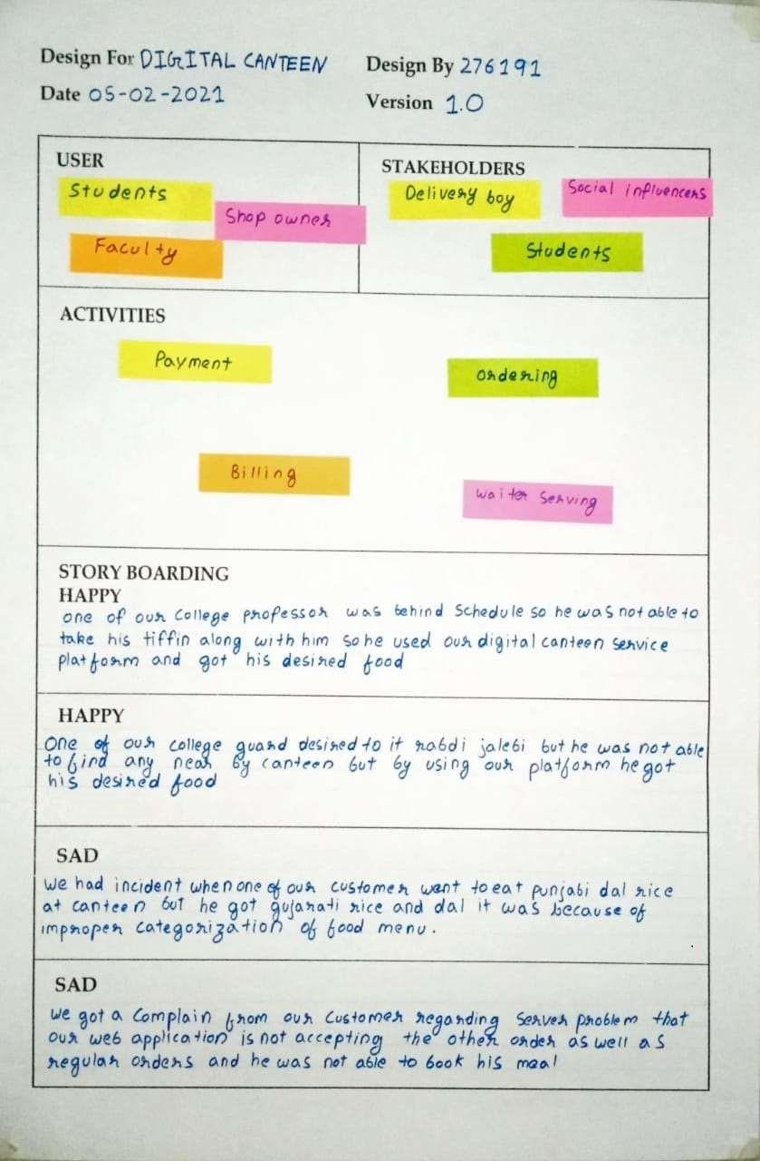

Fig. 2.2.2 Empathy Mapping Canvas

* + 1. Ideation Canvas





Ideation canvas is needed when we've reached the point where we got an eye on issue/problem/difficulty in performing tasks by our subject (say, user). This canvas performs as the front gate to implement our idea in everyday real life.

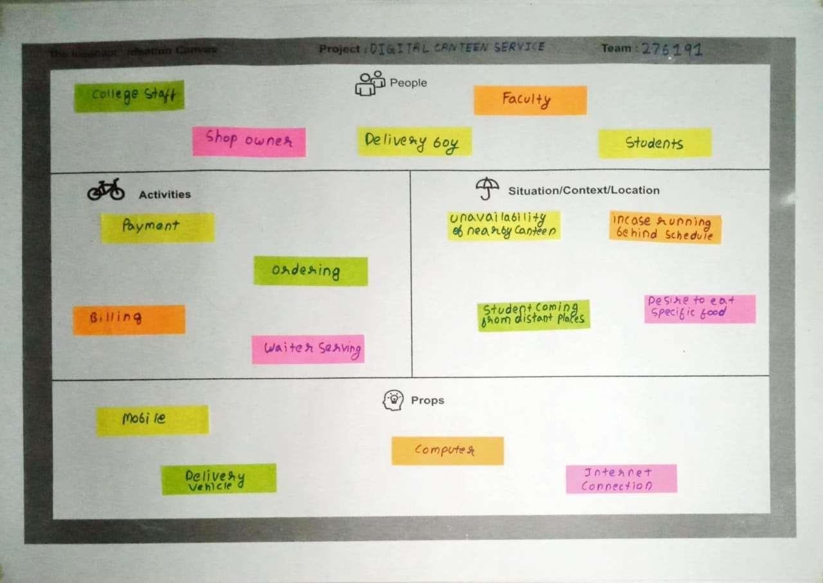

Fig. 2.2.3 Ideation Canvas Some of the iterations observed in our domain are:

1. Students were facing issue that incase running behind the schedule they do not have time to carry their food from the home.
2. Near stall as lot of people come at a single time the place become very crowdy and unpleasant.
   * 1. Product Development Canvas:

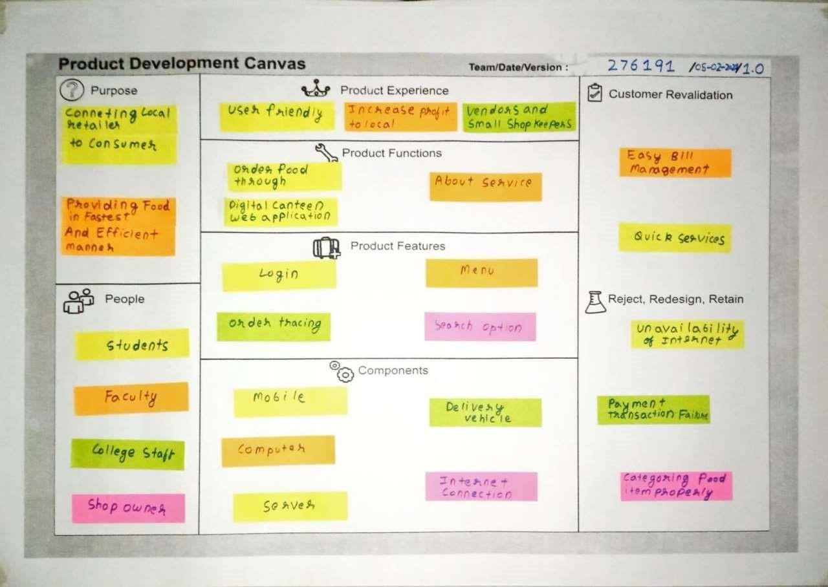

Fig. 2.2.4 Product Development Canvas

Purpose

The basic purpose of development of this project is to bring local retailer to consumer which are students, college staffs, guards etc.

This will benefit both the ways -

1. To increase the profits of all the local retailer in particular area.
2. It will also benefit the students, staffs etc. it will help them to receive the best services from the local retailer near them which also tackle obesity issue.

People

Here we specifically include the people who are going this product -

* 1. Student
  2. Faculty
  3. College staff
  4. General Staff

|  |  |
| --- | --- |
| Product experience | |
|  | 1. Promotes make in India 2. Avoid long queues and hence minimizes customer’s   inconvenience 3. Reduces delivery time compared to other website  4. Safe to use. |
|  | Products function   1. Order food through Digital canteen web app. 2. Providing best and reliable services to the user. |
|  | Product features   1. Provide login and registration facility. 2. Order can be easily traced by using track. 3. Menu option for food items and search option can be found. |
|  | COMPONENTS |

Here we include all the major modules that are included in the application-

1. Login
2. Admin
3. Computer
4. Server
5. User
6. Billing
7. Shipping





1. Mobile

Customer re-validation

Here we observe from the feedback of the customer that the re validation of various entity such as easy bill management quick services.

Reject, Redesign, Retain

We found system can be fail in some obvious condition such as unavailability of internet, food item, payment transaction failure and categorizing food item properly.

* 1. Literature Review / Prior Art Search

1. Zomato:

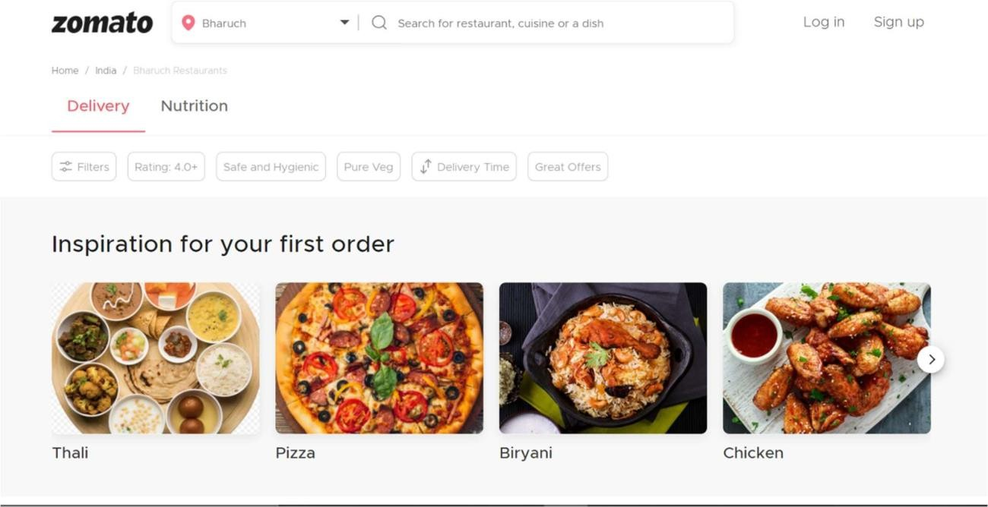

Figs. 2.3.1.a





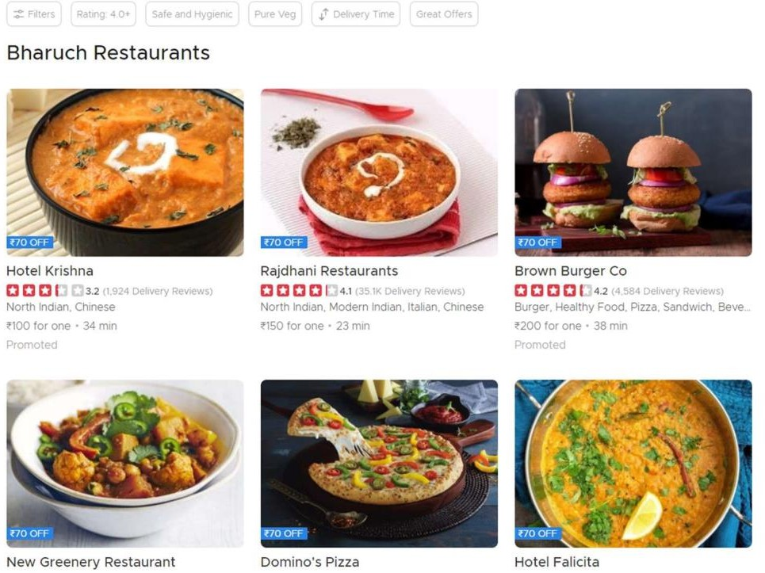

Figs. 2.3.1.b





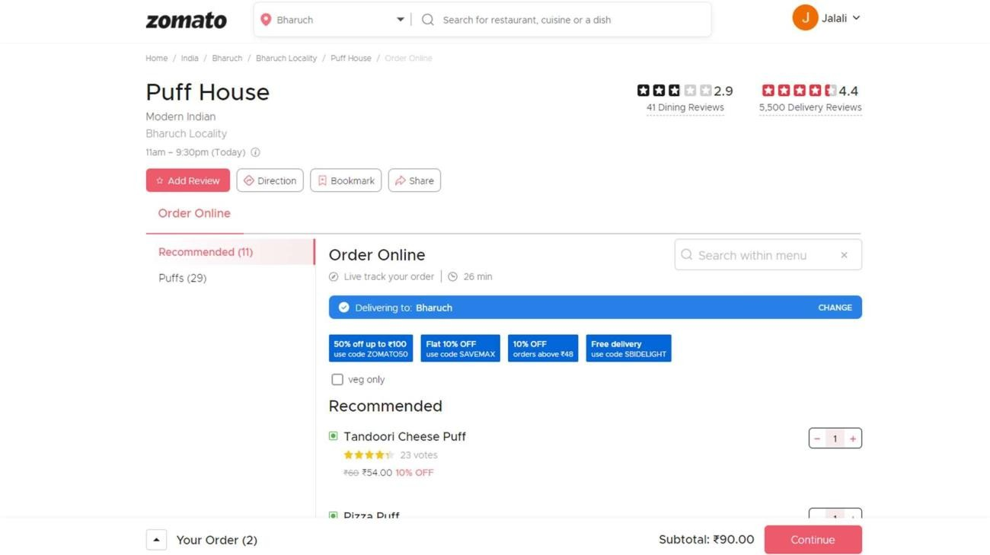

Fig. 2.3.1.c





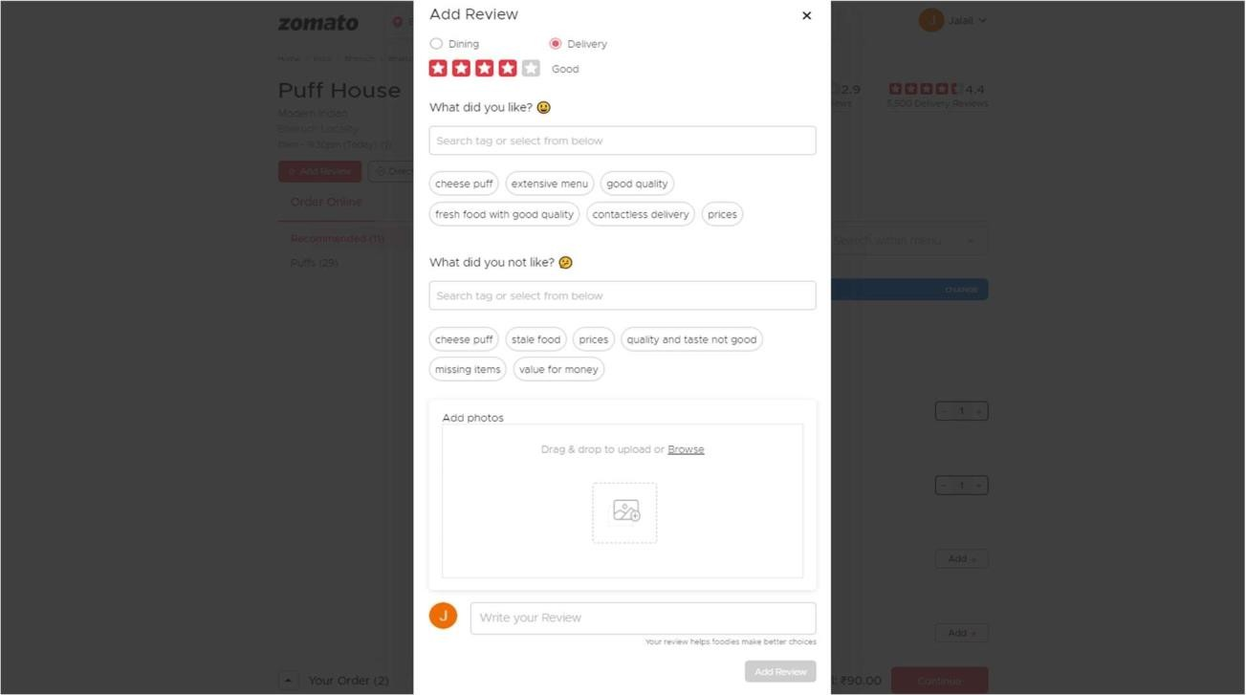

Fig. 2.3.1.d

In the zomato we observed that review section is more convenient and additionaly user can add image as well. It is a very good feature to get a constructive feedback from a customer for different vendors. The problem with zomato is their interface which is a bit complicated to understand and use.

1. Swiggy:





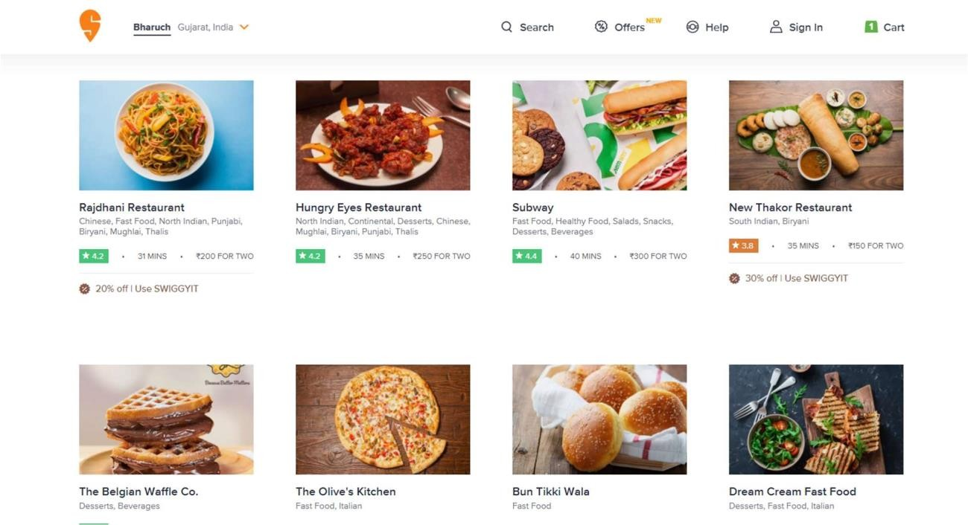

Fig. 2.3.2.a





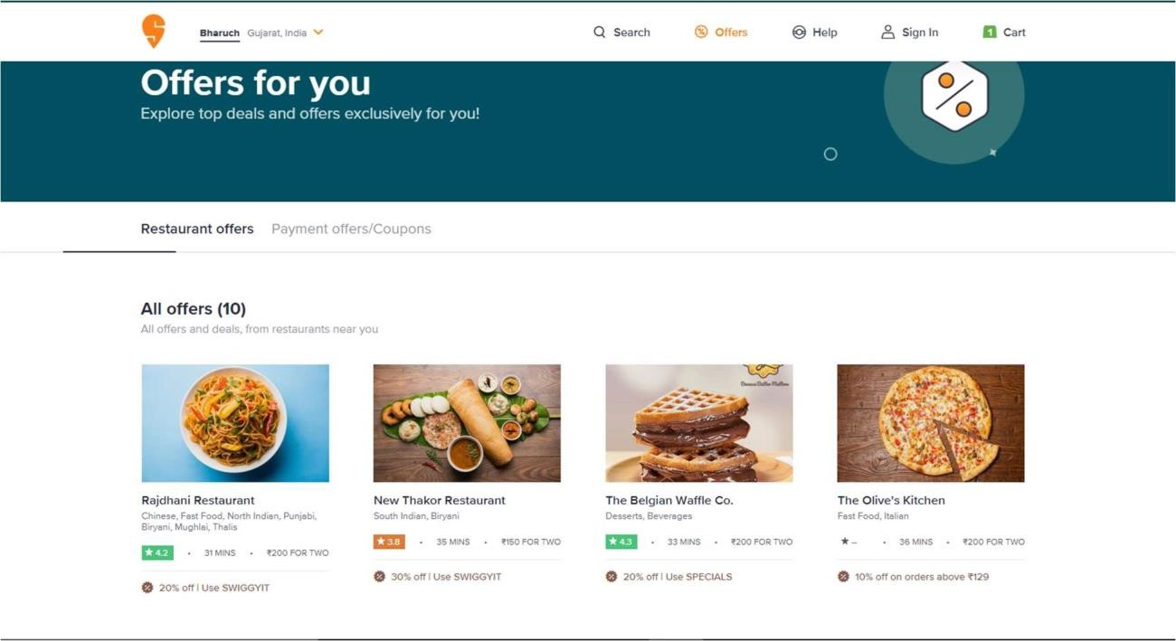

Fig. 2.3.2.b

Swiggy has more convenient user experience, a filer option on various food items, a search option on the top of all this they have very convenient discount and offer page. Which is

very useful to attract the target user. We found some bad rating on swiggy regarding their delivery service which is a major drawback of it compare to Zomato.

1. Biryani by Kilo:





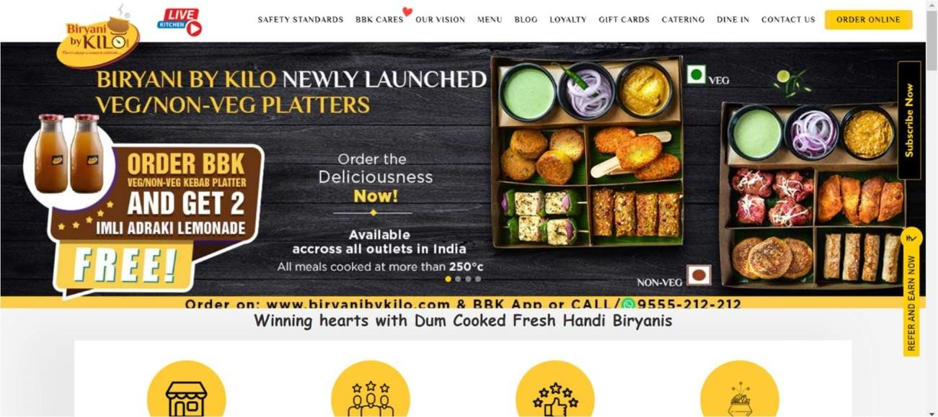

Fig. 2.3.3.a





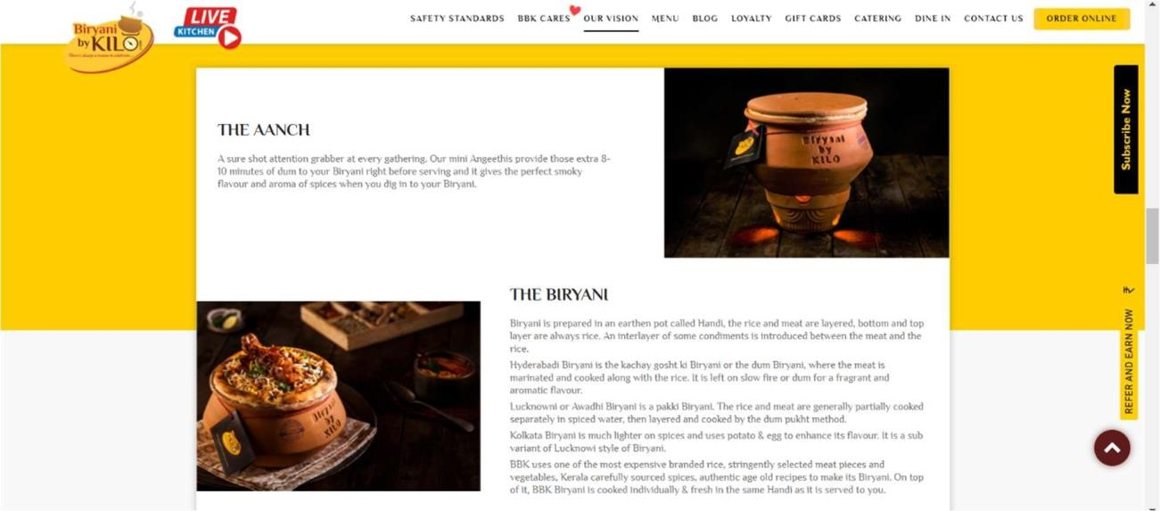

Fig. 2.3.3.b

Biryani by Kilo's Unique Selling Proposition is to “dum cook” fresh biryani for every individual order, and deliver biryani in that very handi to the customer. To enhance the biryani experience, the company also sends earthen angeethis with each order, to preserve the smokey flavour and aroma of the spices used in the rice.

It’s a user specific approach a target user is limited in this platform, only a people who wants to eat the specific food in this manner will only go with this.

1. Digital Dabbawalas:





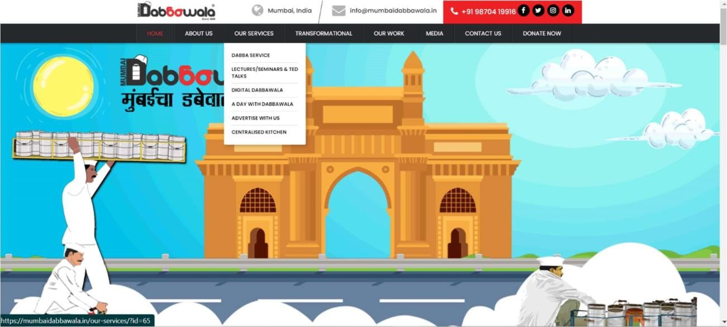

Fig. 2.3.4.a





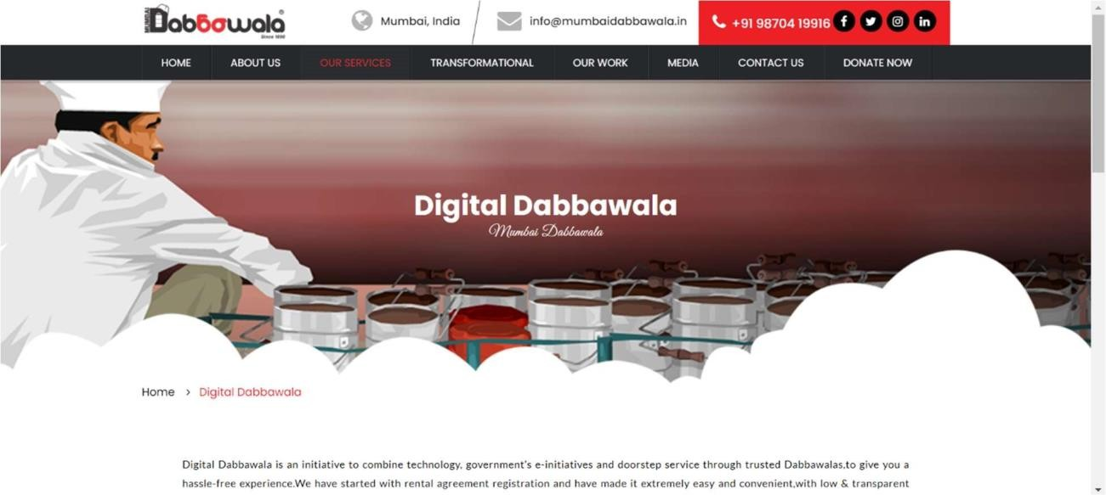

Fig. 2.3.4.b

Mumbai Dabbawala is the one of the oldest food delivery platform. Dressed in white outfit and traditional Gandhi Cap, Mumbai Army of 5,000 Dabbawalas fulfilling the hunger of almost 200,000 Mumbaikar with home-cooked food that is lug between home and office daily. Now this platform is digitalized as different service of the business named after Digital Dabbawala.

A key learning from the dabbawalas is a consistency and accuracy, most of the food delivery has main issue with delivering food on time and dabbawalas do this very efficiently. A looking at

dabbawalas service they have only 2-3 services they are not utilizing there network efficiently.

1. Uber Eats





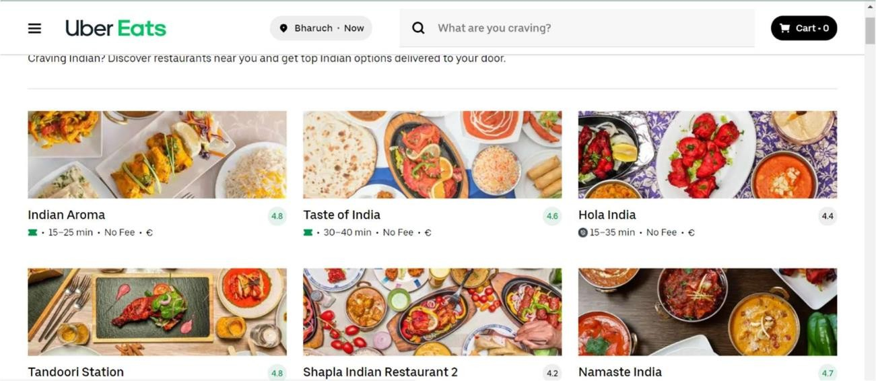

Fig. 2.3.5

Uber Eats is the one of the leading organizations globally. The Uber Eats has pretty good

availability in serval countries. Scheduled delivery is the feature which was first introduced by uber eats.

Uber Eats enables taste preferences by suggesting cuisines according to past histories and existing contextual information. Therefore, users get customized choices of food from different restaurants at the push of a button.

Here as well user interface is bit hard to understand.

* 1. Feedback/Summary of the learning from Reverse Engineering activity:

Reverse engineering is a process of disassemble and examine or analyze in detail any product to discover the concepts involved in manufacture usually to produce something similar. it's not limited to this it is very useful for finding a solution for the problems. we





have observed a lot of platforms working on same concept and found some useful features which can enhance our project.

We have observed a few very interesting aspects on the different platform such as the

leading platform in the industry has additional vendors who already have their platform but also doing business on these leading platforms. In addition, we learned about Unique selling proposition how the leading organization has their usp and how they maintain position in market with that.

# Chapter 3. Phase 2: Predesign

* 1. Pre-design calculation

Hardware requirements:

* + - Laptop
    - Smart phone

Software requirements:  ASP.NET

* + - Visual Studio
    - Mysql 2008
  1. Learning Needs Matrx





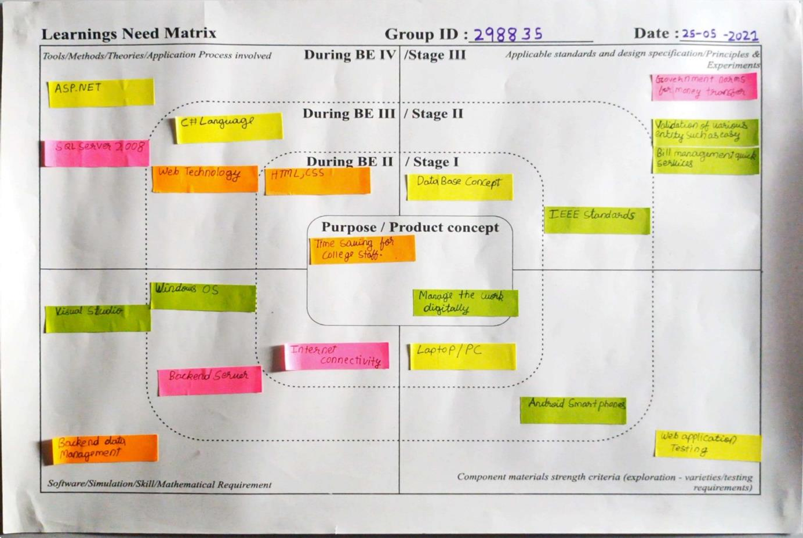





Fig. 3.3.2 Learning Need Matrix

Purpose/Product concept

* + - Time saving for college staff and students
    - Manage the product digitally

Tools/Methods/Theories/Application Process Involved

* + - ASP.NET
    - Sql server 2008
    - C# language
    - Web technology
    - Html
    - CSS

Applicable standards and design specification/Principles and Experiments

* + - Government norms for money transfer
    - Validation of various entities such as easy bill management quick service IEEE standards

Component material strength criteria

* + - Laptop / PC
    - Web application testing
    - Android smartphone

Software/Simulation/Skills/Mathematical Requirement

* + - Visual studio
    - Backend data management
    - Backend server
    - Windows OS
    - Internet connectivity





# Chapter 4: Prototype Model

* 1. Features / Functions of proposed system
     + Food ordering
     + Register
     + Login
     + Product page
     + Cart
  2. 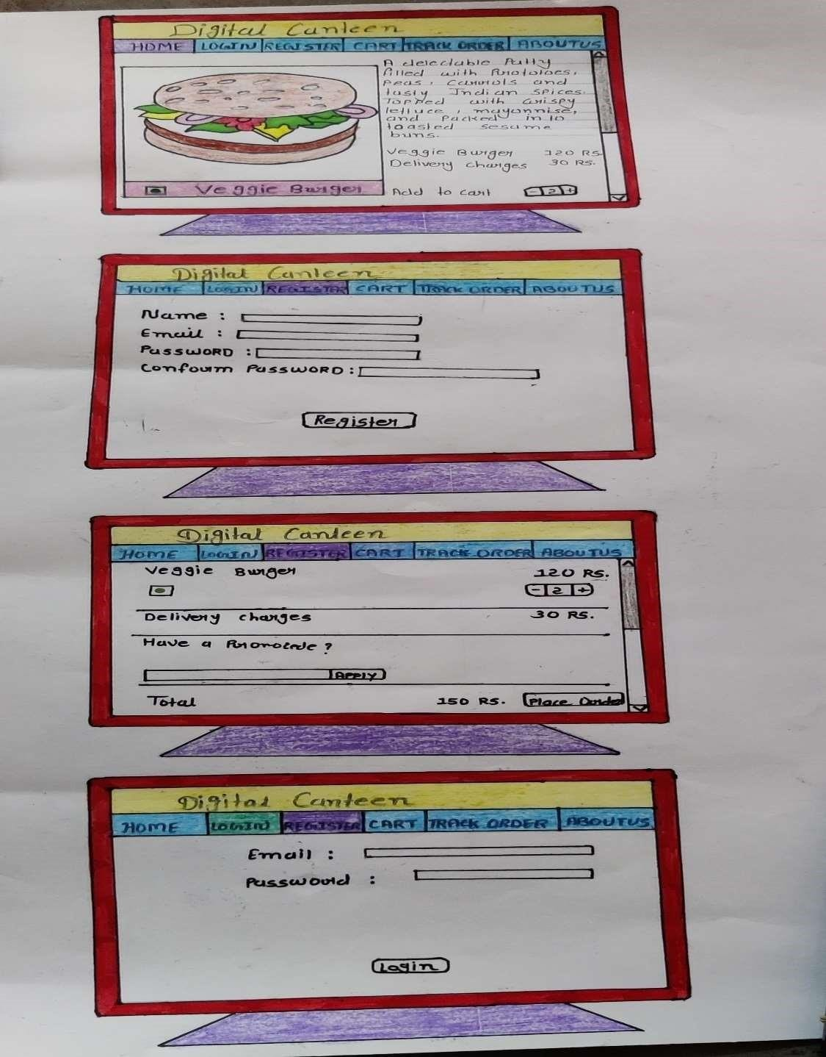Fast prototype Model / Conceptual Plan Layout:

# Conclusion

Fig. 4.2 Fast prototype

By applying reverse engineering on our project digital canteen service, we found very interesting features and strategy of different platforms. By examining all the aspects, we can conclude that Unique selling proposition is very important in online food delivery platform. In addition, using Machine learning a platform can be optimised for smooth user experience.







# References

http[s://ww](http://www.researchgate.net/)w.r[esearch](http://www.researchgate.net/)g[ate.net](http://www.researchgate.net/) https://help.ethnohub.com/guide/aeiou- framework

https://online.visual-

paradigm.com/diagrams/templates/empathymap/empathy-map- canvas/ https://scholor.google.co.in